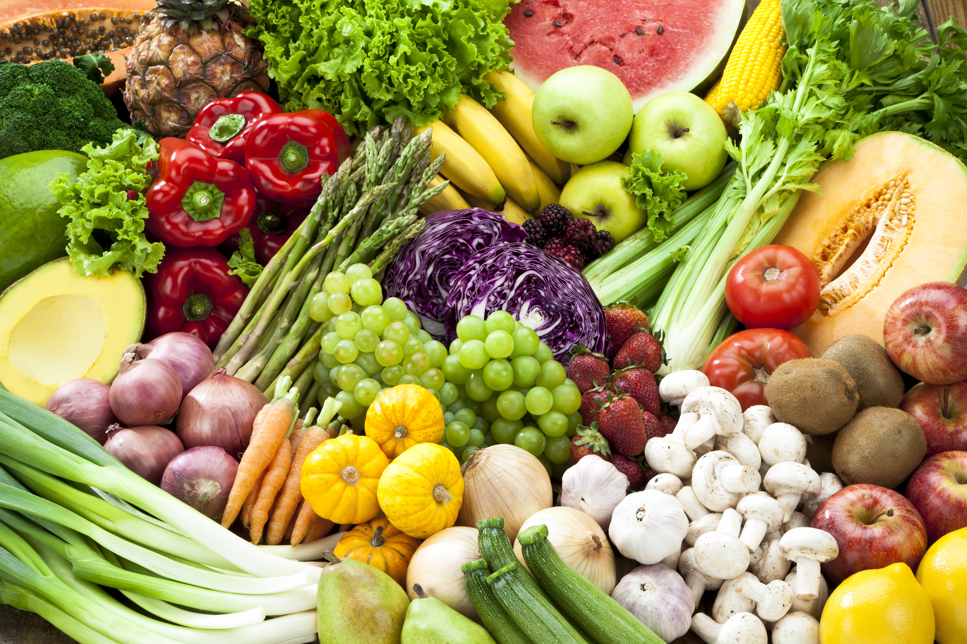

Share the Fresh

Project Design Breakdown

(www.sharethefresh.life)

Raquel Jonathan Austin Shaun

# Concept

The idea behind the project was a web app that given an image of food would be able to narrow the photo down to a list of produce using AI vision and then provide the user with the following information:

-A recommended dietary breakdown using the produce in the image

-Nutritional information on the food products in the photo

-A list of charities that the excess or unhealthy foods could be donated to

The end goal was to help households eliminate the unneeded produce in there homes while promoting the support of charities with food products.

# Future Implementations

-Accounts for members

The initial design lacked this out of time constraints but would’ve allowed users to create an account linking their produce donations and diet to their personalized account.

-Gamification:

Implementing the feel of a video game into the UI make the app more user friendly and fun while promoting the usage of the game. Possible ideas for this implementation include digital badges for members, social media shoutouts for members

-Accounts for members

# Design

The design of the project was broken down into fragments that would be implemented together.

1.The web design was done using Adobe Dreamweaver with Bootstrap and JavaScript to produce an intuitive yet simple interface that could make and display information from API requests.

2.The backend consisted of making API requests in JavaScript to the Artificial Intelligence API called Clarifai that has a premade model trained to interpret images for the types of produce in the given image. This information would then be parsed into a breakdown that correlates the specific food with its dietary information using another API (Unknown)

4. There was a lot of important research that needed to be done to find an API that could provide relevant information on the determined produce along with the research required to build a solid need based dietary plan.

3. The general layout was based off a previous website we created called [www.logosuggest.com](http://www.logosuggest.com)

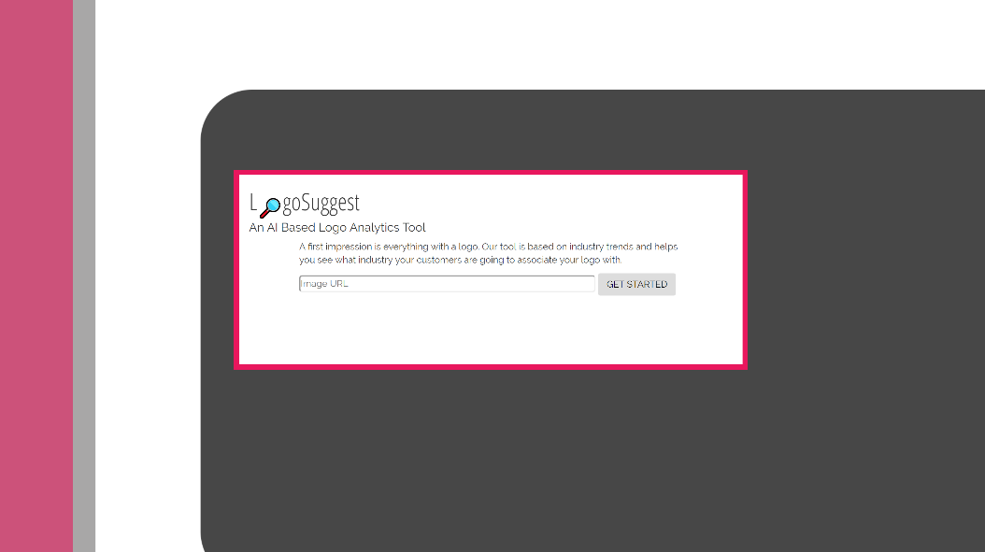

# Prototype

We were able to get a working model that could interpret the images of food provided by a user to a reasonable accuracy that would allow user to add or remove food products not shown. The user could then use their own input of Calories, protein, and Fats to get a recoemnadtaion for meals and then determine the excess food they have that could easily be donated to the any of the shown local charities

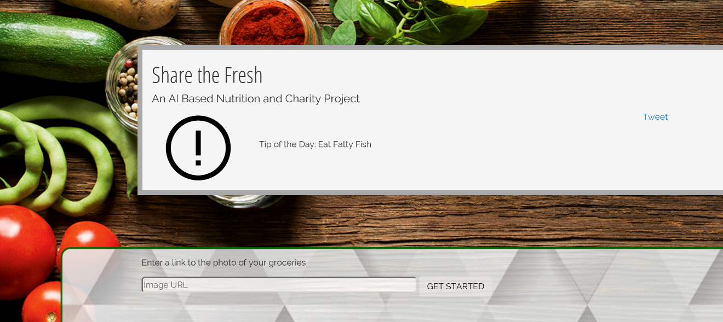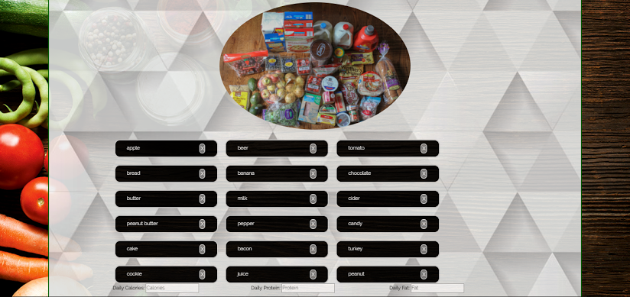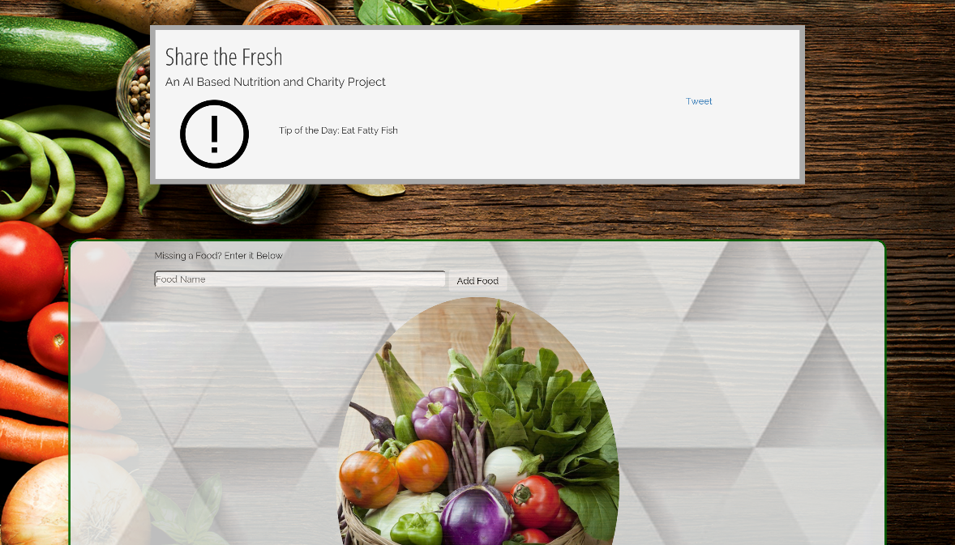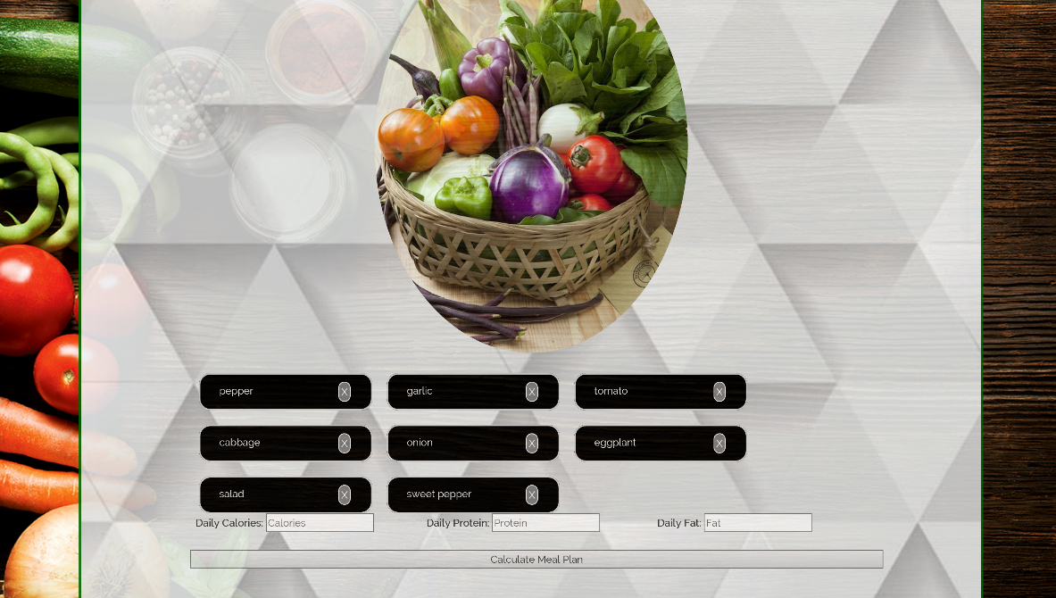

# Resources

In the process of building the project we utilized:

-Github

-Adobe Dreamweaver

-Adobe XD

-Domain.com